
Tool 6.3
Business Plan Elements

Strategic Plan
Destination: Mission, Vision, Objectives, Goals, Guiding Principles. Fill in current best thinking:
Mission: What called to do and why it matters
Vision: What – Picture of success in which all can envision themselves
Value Proposition: What’s in it for them
Objectives: Broadly defined, qualitative performance requirements
Goals: The quantitative measures of the objectives that define success
Values/Guiding Principles: That you will not compromise on the way – including the core nature of the business (design, produce, deliver, service)

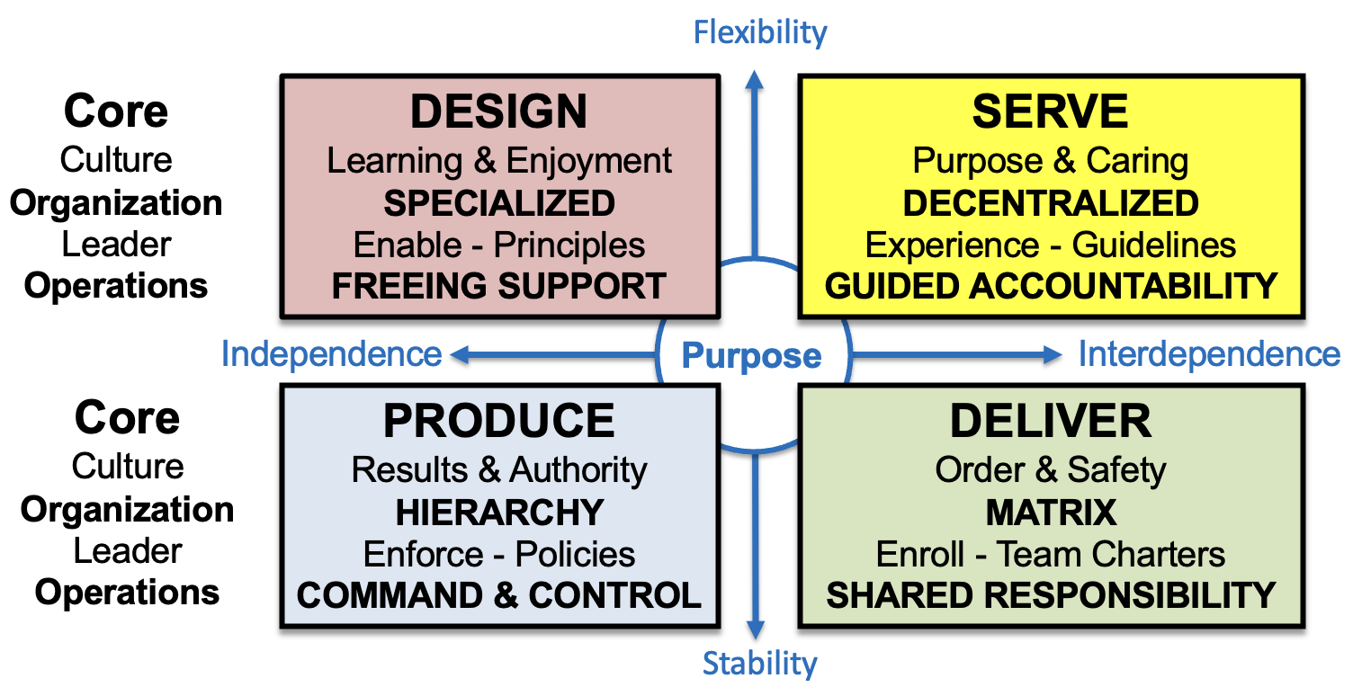

Current Reality: SWOT Summary
Lay out internal strengths and weaknesses and external opportunities and threats
Link the strengths and opportunities into points of leverage
Link the weaknesses and threats into business issues

Bridge the Gap: Strategy, Culture, Organization, Operations
Overarching strategy:
Strategic Priorities/Resource allocation:
(e.g. Predominant/Top 1%, Superior/Top 10%, Strong/Top 25%,
Above average Top 50%, Good enough/scale, Not do/outsource)
Identify your top three strategic priorities in line with your overarching strategy and your resource allocation choices for each of those areas.
e.g. Staff superior at anticipating and delighting guests
Strong ingredients and recipes
Good enough physical plant - buildings
Resource Plan (requirements, application, sources)
Human: Lay out future organization and capability needs, current reality and plans to fill those gaps in terms of requirements, application and sources.
Financial: Lay out future financial needs, current reality and plans to fill those gaps in terms of requirements, application and sources.
Physical: Lay out future needs around physical plant and assets, current reality and plans to fill those gaps in terms of requirements, application and sources
Technical: Lay out future technical needs, current reality and plans to fill those gaps in terms of requirements, application and sources
Operational: Lay out future operational needs, current reality and plans to fill those gaps in terms of requirements, application and sources

Action Plan: Priority Actions Timing Accountability Linkages
Near-term
Longer-term
Lay out actions to be completed on what timing, by whom with what linkages.
Near-term actions are required to deliver current objectives and goals.
Longer-term actions are required now to build capabilities required to deliver future goals.
General planning steps: 1) Priorities (Get input or agreement)
2) Actions (Get input or agreement)
3) Timing, Accountability & Linkages (To sync plans)

Performance Management Plan
Operating and financial performance standards
Lay out operating and financial performance standards – what you’re going to measure along the way in tracking success.

Management Cadence:
Annual (Priorities):
Monthly (Programs):
Weekly (Projects):
Lay out your cadence for tracking and managing progress. Your priorities (generally managed quarterly) are made up of programs (managed monthly), which are made up of projects (managed weekly), which are made up of daily tasks (perhaps more frequently in a crisis.)

