Tool 24.1 Communication and Presentation Planning
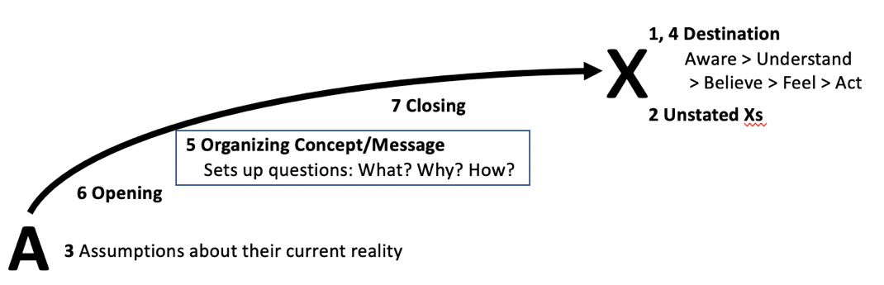
1. Identify your destination. Impact on audience: Aware, Understand, Believe, Feel, Say, Do.
2. Be explicit about unstated Xs. How audience should think and feel about you. (Hidden X)
3. Assess current reality. Where audience is now. Obstacles. Rumors. Influencers.
4. Reevaluate destination in light of assumptions about audience. Required steps?
5. Bridge the gap with your organizing concept/message
This is key – choosing what to communicate to bridge the gap between the current reality/platform for change and your destination vision. Think through what people need to be aware of, understand (rationally,) believe, and feel (emotionally) to answer the call to action and move from the current reality to that destination. This spawns your organizing concept (strategy)/message (words) and three questions like why listen to you, how think about what you’re saying, what actions they should take that become your presentation framework.
6. Prepare opening. To capture their attention. (For senior executives should probably have a one page/one slide executive summary that makes all your main points.)
7. Prepare closing. To cement your message, knowing that people remember what they see first and last more than what comes in the middle.
8. Deliver the communication.
Implement with the best vehicles in the optimum combination with the best timing – in-person or virtual, synchronous or asynchronous. Get clear on who and what influences whom. This is where you pull in your amplifiers. And don’t forget to plan out how you can best plant the follow-up seeds.
With more detail
1. Identify your destination.
Think through what impact you want to make on your audience. How do you want them to react? How do you want them to feel? What do you want them to do? Get specific about what you want them to be aware of, understand, believe, say and do.
2. Be explicit about unstated Xs.
Think through how you want your audience to think and feel about you (hidden X)
3. Assess current reality.
Figure out where your audience is now and how they got there. What are they aware of, understand, believe? Which aspects of that help? Which get in the way? Consider potential obstacles, negative rumors, hecklers or other sabotage, legal requirements, and unintended consequences of what you say or do. Think about hidden influencers. Scenario planning is often helpful.
4. Reevaluate destination in light of assumptions about audience.
Now go back and relook at your destination. Given what you just laid out about the current reality, can you still get all the way to the target you set in section 1? Or do you need to get there in steps?
5. Bridge the gap with your organizing concept/message
This is key – choosing what to communicate to bridge the gap between the current reality/platform for change and your destination vision. Think through what people need to be aware of, understand (rationally,) believe and feel (emotionally) to answer the call to action and move from the current reality to that destination. This spawns your organizing concept (strategy)/message (words.)
Your organizing concept/message sets up questions, likely including
- Why should anyone listen to you?
- How should they think about what you’re saying?
- What actions they should take?
These are closely related to Ethos, Pathos and Logos. Ethos gets at the intentions and competence of the speaker and their empathy with the audience. (Me.) Pathos is about the feelings the speaker engenders in the audience (You.) Logos is about evidence and facts that will win the audience over, leading them to action. (Us.)
Ideally, you’ll communicate emotionally, rationally and inspirationally:
- Emotionally establishing an emotional connection with your audience (Ethos and Pathos)
- Rationally laying out the brutal facts of the current reality as a platform for change (Logos I)
- Inspirationally pointing the way to a vision of a better future with a call to action. (Logos II)
These form the heart of your communication, pulling in the right personal stories to establish your intentions and competence, the right illustrations to connect with the audience, and the right evidence, facts and clear next steps to compel them to action. (“Right” means necessary and sufficient.)
Craft your message based on what people need to be aware of, understand, believe, and feel to move from current reality to the desired destination.
Platform for change:
Vision of a better future:
Call to action:
=> Organizing Concept/Message headline:
Answer three questions in your communication points:
- Why anyone should listen to you (Ethos/Me – setting up emotional connection)
- How they should think and feel about what you’re saying (Pathos/You – driving emotional connection).
- What they should do next (Logos/We – rational evidence leading to inspirational action).
6. Prepare opening. To frame and capture their attention. (Note default option for “presenting” to senior executives should probably be a one page/one slide executive summary that makes all your main points. A good format for that (and the basic flow of your presentation) is:
- Headline message (i.e. “Seeking your agreement to buy X”)
- Situation/problem/platform for change (Company X is siphoning off customers)
- Desired impact/solution/vision of a better future (Buy, merge, protect our base, and grow)
- Plan/next steps/call to action (Offer $XXB all-cash. Specific steps.)
7. Prepare closing. To cement your message, knowing that people remember what they see first and last more than what comes in the middle.
8. Deliver the communication. Implement with the best vehicles in the optimum combination with the best timing – in-person or virtual, synchronous or asynchronous. Get clear on who and what influences whom. This is where you pull in your amplifiers. And don’t forget to plan out how you can best plant the follow-up seeds.
What are the best vehicles to reach your audience or constituents?
What is the optimum combination?
What is the best timing to release the message?
Who and what influences whom - amplifiers?
How do you best plant the follow-up seeds?

1. Much of this is based on work by Speakeasy’s Sandy Linver, also laid out in her book Speak and get Results, Simon and Schuster 1994

